
ANKARA YILDIRIM BEYAZIT UNIVERSITY
FACULTY OF ENGINEERING AND NATURAL SCIENCES

RESEARCH ON THE MEDIATING ROLE OF CYBER SECURITY IN THE EFFECT OF ARTIFICIAL INTELLIGENCE AND BLOCKCHAIN ON MANUFACTURING RESILIENCE

Undergraduate Thesis By
Betül Orhan

Department of Industrial Engineering
January, 2025
ANKARA

ETHICAL STATEMENT
In this thesis study that I prepared in accordance with Ankara Yıldırım Beyazıt University Institute of Science and Technology Thesis Writing Rules;
- I obtained the data, information and documents I present in the thesis within the framework of academic and ethical rules,
- I present all information, documents, evaluations and results in accordance with scientific ethics and moral rules,
- I cite all of the works I used in my thesis with appropriate references,
- I have not made any changes to the data used,
- The work I present in this thesis is original,
I hereby declare that I accept all losses of rights that may arise against me in any
other case.
05/01/2025
Betül Orhan

ACKNOWLEDGMENTS
On this occasion, I would like to thank my teacher and advisor, Dr. Cihat Öztürk, for his support, guidance, encouragement and contributions to the projects. He showed his support from the early stages of the project to the end. It was an honor and a pleasure to work with him. I would also like to thank the participants who took the time to analyze this project and participated in the survey.

Betül Orhan

RESEARCH ON THE MEDIATING ROLE OF CYBER SECURITY IN THE EFFECT OF ARTIFICIAL INTELLIGENCE AND BLOCKCHAIN ON MANUFACTURING RESILIENCE

ABSTRACT
This project aims to analyze the mediating role of Cyber ​​Security (CS) in the impact of Artificial Intelligence (AI) and Blockchain (BC) technologies on Manufacturing Resilience. Using theoretical knowledge, inferences were made, and survey questions were created. Survey questions were presented to a large population and information was collected. The collected information was then analyzed using Structural Equation Methodology (SEM). Project; Contains introduction, literature review, method used, data collection, results and recommendations.
Within the scope of the project, "Does Cyber ​​Security have a mediating role in the impact of Artificial Intelligence and Blockchain technologies on Manufacturing Resilience?" "What is the relationship between cybersecurity and manufacturing resilience?" Answers to these questions have been sought. In this context, literature research on the subject was conducted and survey questions were put forward. Data on the subject was collected.
This study aims to emphasize the sectoral importance of cyber security by revealing the impact of cyber security on strengthening resilience against crises in production processes. In this way, it was aimed to help production companies have a healthier production process.
By analyzing the findings, the ability to achieve the aim of the study was evaluated. It aims to provide practical suggestions to manufacturing companies in line with the findings.
Keywords: Cyber ​​Security, Artificial Intelligence, Blockchain, Manufacturing Resilience

YAPAY ZEKA VE BLOK ZİNCİRİNİN ÜRETİM DİRENCİNE ETKİSİNDE SİBER GÜVENLİĞİN ARACILIK ROLÜ ÜZERİNE ARAŞTIRMA

ÖZET
Bu proje, Yapay Zeka ve Blockchain teknolojilerinin Üretim Direnci üzerindeki etkisinde Siber Güvenliğin aracılık rolünü analiz etmeyi amaçlamaktadır. Teorik bilgilerden yararlanılarak çıkarımlar yapılmış ve anket soruları oluşturulmuştur. Anket soruları geniş bir kitleye sunulmuş ve bilgi toplanmıştır. Toplanan bilgiler daha sonra Yapısal Eşitlik Metodolojisi kullanılarak analiz edildi. Proje; Giriş, literatür taraması, kullanılan yöntem, veri toplama, sonuçlar ve önerileri içerir.
Proje kapsamında "Yapay Zeka ve Blockchain teknolojilerinin Üretim Direncine etkisinde Siber Güvenliğin aracı rolü var mı?" "Siber güvenlik ile üretim dirençliliği arasındaki ilişki nedir?" Bu soruların yanıtları arandı. Bu bağlamda konuyla ilgili literatür araştırması yapılmış ve anket soruları ortaya konmuştur. Konuyla ilgili veriler toplandı.
Bu çalışma, siber güvenliğin üretim süreçlerinde krizlere karşı dayanıklılığı güçlendirmedeki etkisini ortaya koyarak siber güvenliğin sektörel önemini vurgulamayı amaçlamaktadır. Bu sayede üretim yapan firmaların daha sağlıklı bir üretim sürecine sahip olmalarına yardımcı olmak amaçlandı.
Bulgular analiz edilerek çalışmanın amacına ulaşma yeteneği değerlendirilmiştir. Elde edilen bulgular doğrultusunda üretim firmalara pratik öneriler sunulması amaçlanmaktadır.
Anahtar Kelimeler: Siber Güvenlik, Yapay Zeka, Blockchain, Üretim Direnci

CHAPTER 1
INTRODUCTION
Resilience is the ability of individuals, organizations and systems to be resilient. When an unexpected or undesirable situation occurs, an individual, an organization or a system that can quickly get rid of the negative effects of the situation and keep the time until the return to normal state at a minimum level is strong in terms of resilience. An individual, organization or system equipped with resilience; It has advantages such as being able to cope with crises, adapting to change, sustainable and long-term success, and providing competitive advantage. (Hornor, 2017) It is possible to compare Resilience to a body recovering from an illness or to a river that is blocked in front of it and is looking for a new path.
Even though the human immune system is damaged and shaken by the effect of the disease, it struggles to recover. In the meantime, s/he learns something new and becomes stronger by learning from what s/he has learned. At the end of the process, the person not only recovers but also becomes resistant to the next similar disease. (Wu, ve diğerleri, 2013)
When a river is dammed, the river can find a new path. When face-to-face education was not possible due to the COVID-19 epidemic, we did not give up on educating people. Instead, the river found a new path. By turning to online platforms, it has created a new riverbed for itself. As the river finds its way, it also transforms its environment; just as the education system gains new competencies and flexibility when dealing with the crisis. (Naidu, 2021)
The diseases mentioned here or the obstacles blocking the river become more unlikely thanks to cyber security applications. This idea is put forward in this study. The research to be conducted is to test whether cyber security is an improving or deteriorating factor here. As cyber security has become more prominent with developing technologies and its critical importance has been seen, it has become necessary to test its impact in this field.
Resilience refers to the resilience and adaptability of systems to challenges in every sector. Each sector uses resilience as an adaptation and growth opportunity according to its own dynamics. For example, (Kantur & İşeri Say, 2012)
- In the healthcare sector, during crises such as pandemics, hospitals continue their services by increasing their intensive care capacity and switching to digital health solutions.
- In the education sector, activating educational technologies allows students and teachers to continue the learning process in case of any situation that may disrupt education.
- The financial sector maintains customer trust with solid infrastructures and effective risk management strategies in the face of economic crises or cyber attacks.
- The agricultural sector continues its production with sustainable irrigation systems and product diversity in environmental difficulties such as drought.
- In the technology sector, resilience makes it possible to maintain uninterrupted services with backup and cyber security measures against data loss and system failures.
The situation in the manufacturing sector, which is the subject of this study, needs to be addressed separately.

Manufacturing Resilience
The degree to which production activities can withstand or quickly recover from interruptions that pose a threat to production operations is called manufacturing resilience. (Mwangola, 2018) Manufacturing resilience can also be defined as the ability of a production enterprise to function at a reasonable level in the presence of undesirable situations. (Kusiak, 2020)
Manufacturing has evolved over time, especially with the influence of Industry4.0. In this process, resilience is important for manufacturing companies. Operation in production may be interrupted by unexpected reasons such as natural disasters, equipment failures, worker strikes, economic crisis, bankruptcy, intentional sabotage, terrorist attack or cyber attack. Even if the probability of occurrence is low, flow interruptions that may have a high impact can threaten the dynamism of companies. (Sawik, 2020) When a negative situation in a company cannot be tolerated with resilience, it can have a worldwide impact. For example, after the severe earthquake in Taiwan in 1999, the supply of semiconductor materials offered by Taiwan's manufacturing sector to the world was negatively affected. This has revealed disruptions in the global supply chain, price increases and global dependency around the world. (Sheffi, 2005)
According to Kusiak (2020), for a durable manufacturing system there must be six durability features. The first of these is the energy source, as meaningful production is not possible without a solid energy source. For example, a sustainable energy source. Secondly, they are the materials that are the building blocks of a production. For example, the method of alternating the use of important materials. Thirdly, assets and processes are the entities that perform the work in which raw materials are transformed into products. For example, regular equipment maintenance and the introduction of new production technologies into processes. Fourthly, the transportation applied to deliver the completed product to the end user. For example, smart route systems. Fifthly, the supply chain in the process from raw material procurement to production. For example, traceable transparent supply chain systems. Sixth and finally, it is information system communication that meets the requirements for business process management. For example, strong computer systems in terms of cyber security. These attributes can be seen in Figure 1. In this research project, the research questions were prepared with reference to these six attributes.
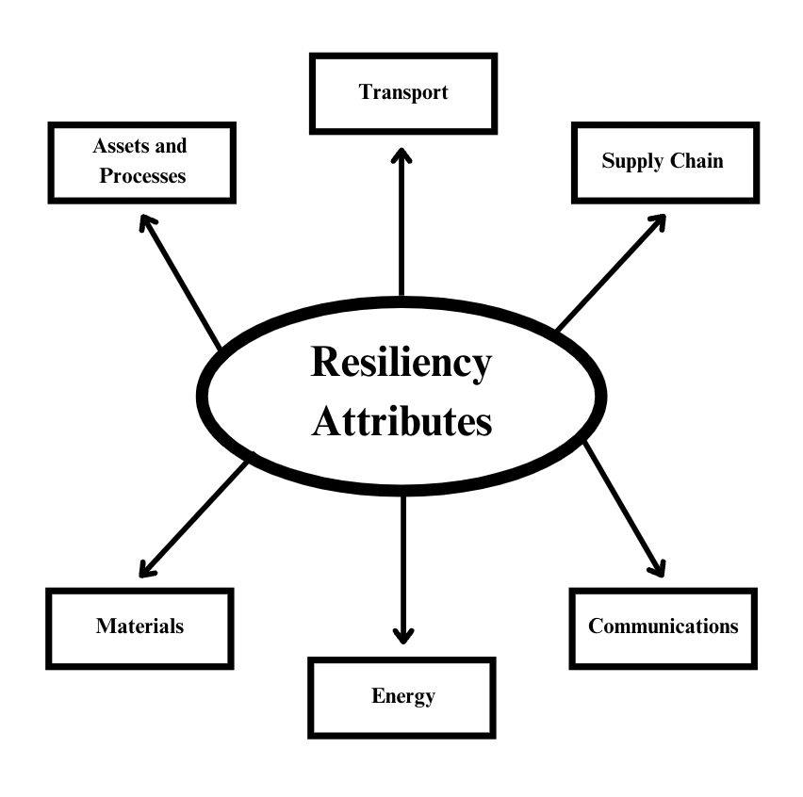
Figure 1: Traditional Manufacturing Resiliency Attributes
When the studies conducted for manufacturing resilience are examined, it is seen that the application of Industry 4.0 applications in manufacturing positively affects manufacturing resilience. (Nakandala, 2024) Artificial intelligence and blockchain, which are components of industry 4.0, will be the independent variables of this study. The cyber security factor that has an impact on these variables will be included as a mediating variable.

Cyber Security
Cybersecurity is the practice of protecting computer systems, networks, software and data against digital threats. It is a system consisting of three basic building blocks: confidentiality, integrity and availability. Confidentiality is the precautions taken to prevent information from falling into the hands of people who do not have permission to access it. Integrity is the precautions taken to ensure that it is not altered by unauthorized persons and remains original. Availability means that it can be stored and used by authorized persons when needed. It is a defense mechanism in case of a violation of these rules, that is, unauthorized access, data theft, malware and other cyber threats. (Lynn, 2010)
Cyber ​​security is of great importance, especially in the manufacturing sector. because it ensures the continuity and security of operations. With the digitalization of production processes, production lines can be exposed to cyber threats, resulting in production line stoppages, data loss, and even financial loss. Additionally, the security of critical infrastructures such as supply chain, transportation and energy also depends on cybersecurity measures. (Yeşilyurt, 2015)
It is a fact that home risks, which are expected to be around frequently, will emerge more clearly as loss studies begin. It is possible to examine how cyber security is used within military units at the national level, for example, in studies such as "From Bombs to Bytes: Role of Cyber Security in National Security and Importance of Artificial Intelligence in Cyber Security". (Karasoy & Gezici, 2023)

Artificial Intelligence
Artificial intelligence is a technology that enables machines to be equipped with data, perform human-like tasks and keep up with new data. For this, computers need to analyze large data sets, allowing certain patterns to emerge and predictions to be made. At the same time, artificial intelligence; Has potential in data analysis, learning, problem solving and decision making.
The most important aspect of artificial intelligence, which has a very wide scope, is the potential it offers to businesses to increase efficiency, reduce the error rate and produce new things. It makes a very important contribution to ensuring operational durability, especially in the production sector, with its uses such as reducing error rates by better use of resources, demand forecasting and inventory areas in the logistics and supply chain management phase, and predictive maintenance applications. (Jan , Ahamed, Mayer , Stumptner , & Kuusk, 2023)
Artificial intelligence plays a central role in increasing manufacturing resilience because it facilitates the adaptation of production processes. Artificial intelligence can reduce supply disruptions by unraveling nodes in the supply chain. As a matter of fact, if there are defective parts of the system and their expectations, it can accelerate the repair of the production line. Therefore, the production process becomes more efficient and flexible. Dohale, Akarte, Gunasekaran, and Verma (2022) show how artificial intelligence, with its effects, strengthens durable production systems.

Blockchain
Blockchain is the technology that enables safe and indisputable storage and verification of digital data with distributed ledger technology without the need for a central institution. Since each data block is connected by chained cryptographic methods, it is almost impossible to change or delete the data in its original form. (Zhang, 2021)
It is built on the strong building blocks of blockchain such as security, transparency and decentralization. Thanks to the security building block, data is difficult to modify or delete, ensuring data integrity. Thanks to the transparency building block, all transactions can be monitored by participants in the network, which creates trust. Thanks to the decentralization building block, transactions can be carried out without depending on a single authority, which eliminates a single point of error. (Külahlı & Çağlıyan, 2022)
Blockchain technology is used in many sectors. It increases traceability in the production industry by keeping maintenance records and performance data on the blockchain. If the transportation processes of products could be tracked using blockchain, accurate information about delivery times and conditions could be obtained. Everything from the supply of raw materials to the delivery of the final product can be tracked using blockchain to ensure transparency and reliability. Data exchange in production processes on the blockchain protects the security and integrity of data. (Külahlı & Çağlıyan, 2022)

Motivation of the Project
The study also aims to investigate the importance of artificial intelligence and blockchain technologies, which are considered important for the continuity and development of production durability in today's industry, considering that cyber security is an intermediate function. With the increase in competition in today's industry, it has become an inevitable necessity to rapidly replace new technologies and integrate these technologies effectively. In this context, we aim to investigate an existing knowledge-friendly gap in relevant fields.
My personal motivation is that I wanted to become a cyber security expert in my career while studying industrial engineering as an undergraduate. I wanted to find the intersection of these two disciplines that are important to me. I wanted to combine the strategic role of industrial engineering in production processes and the critical position of cyber security today in a project and I wanted to choose such a topic. My graduation project is management, in which, among many things, I will have the opportunity to understand how it will be applied in my academic or professional career.
From an academic perspective, it is quite interesting to explore how a synergy can be achieved between cybersecurity and the combination of AI and Blockchain technologies by imposing a discipline that has a high level of applicability in many sectors, such as industrial engineering. My research aims to make a valuable contribution to the literature by demonstrating the effects of the combination of these areas on the manufacturing sector.
Therefore, it is anticipated that this study will highlight the dependence of the manufacturing industry on the transformation of cybersecurity. AI and Blockchain seem like they could be useful given their possibilities, so understanding what strategies will help us understand the more potential contributions of these technologies will lead to strategies that will help these technologies become more useful and secure. In this sense, our study will not only contribute to theory, but also meet the practical interests of stakeholders in the manufacturing industry, producing important results.

CHAPTER 2
LITERATURE REVIEW
ÜÇ DÖRT TANE ÇALIŞMAYI REFERANS VERİP BAHSEDECEĞİM

CHAPTER 3
METHODOLOGY
Structural Equation Model (SEM) will be used in this study, which focuses on the mediating effect of Cyber Security in the effect of AI and Blockchain technologies on Manufacturing Resilience. SEM is a method of statistical analysis based on the mathematics of how the connection between two variables works and how all variables are related to each other. AMOS program will be preferred for this analysis.
SEM is a method in which multivariate structures are analyzed. With the SEM method, there is a chance to establish a relationship between the observed and hidden variables. Independent variables are concepts that cannot be measured directly but can be linked to observed variables. In this study, AI and Blockchain were considered as independent variables. Mediator variables are variables that change the effect on the observed variable by applying them to undistributed variables. In this study, Cyber ​​Security was considered as a mediating variable. SEM models and correlates the relationships between these variables with both confirmatory factor analysis (CFA) and path analysis techniques and establishes a structure by allowing a series of hypotheses to be tested. (Lin, Ren, Feng, & Li, 2024) Figure 2 shows the structure expected to be constructed using the SEM method.
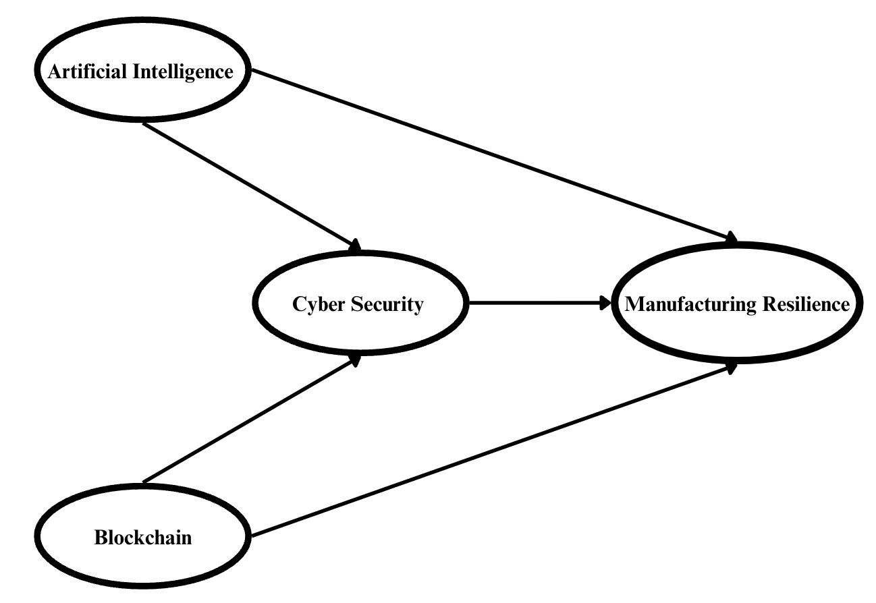

Figure 2: Structural Equation Model of the Project
The SEM method works as follows:
Theoretical Model Development: The concepts examined during the research process and the relationships between them are defined with reference to the literature.
Model Specification: A conceptual model is transformed into a form that contains observed and latent variables and the relationships between them.
Data Collection: The data required to validate the model is collected from a suitable sample. In this study, surveys to be administered to at least 150 people will provide this data.
Estimation of the Model: The parameters of the model are estimated, and the fit indices are evaluated through software such as AMOS.
Evaluation and Revision of the Model: The adequacy of the model is evaluated statistically, and changes are made if necessary.

CHAPTER 4
DATA COLLECTION
Survey questions in Table 1; The survey will be conducted in a five-point Likert style using survey tools such as Google forms to 150 people who are informed in general terms about production durability, cyber security, blockchain and artificial intelligence. Afterwards, the data obtained will be analyzed using the SEM method.
The survey questions were created in line with the inferences obtained from Romero, Stahre, Larsson, and Öhr 's article named Building Manufacturing Resilience Through Production Innovation (2021) and Kusiak’s article titled Fundamentals of Smart Manufacturing: A multi-thread perspective. (2019)

Table 1: Survey Questions
ARTIFICAL  INTELLIGENCE | AI1 | AI-based predictive maintenance applications increase the resilience of production assets to outages.
ARTIFICAL  INTELLIGENCE | AI2 | AI-based transportation route optimizations contribute to preventing disruptions in logistics processes.
ARTIFICAL  INTELLIGENCE | AI3 | AI's demand forecasting and supply chain planning minimizes disruptions in production processes.
ARTIFICAL  INTELLIGENCE | AI4 | AI-based communication networks increase the speed of decision-making in production processes.
ARTIFICAL  INTELLIGENCE | AI5 | AI-based energy optimization systems increase the resilience of energy resources.
ARTIFICAL  INTELLIGENCE | AI6 | AI-based material requirements planning systems increase resilience to supply chain disruptions.
ARTIFICAL  INTELLIGENCE | AI7 | AI is a critical tool to increase resilience in manufacturing processes.
BLOCKCHAIN | BC1 | Blockchain-based recording systems improve the traceability and reliability of assets in production processes.
BLOCKCHAIN | BC2 | Blockchain-based transportation tracking systems increase the resilience of logistics processes against disruptions.
BLOCKCHAIN | BC3 | Blockchain-based traceability systems increase transparency in the supply chain.
BLOCKCHAIN | BC4 | Blockchain-based secure communication infrastructures ensure the reliability of data flow between stakeholders.
BLOCKCHAIN | BC5 | Blockchain-based energy management systems ensure uninterrupted energy supply.
BLOCKCHAIN | BC6 | Blockchain-based traceability technologies increase sustainability in materials management.
BLOCKCHAIN | BC7 | Blockchain is an effective technology to ensure transparency and reliability in production processes.
CYBER SECURITY | CS1 | Cybersecurity protocols increase the resilience of digital assets in AI-enabled production processes against cyber threats.
CYBER SECURITY | CS2 | Strong cyber security protocols in blockchain-supported systems ensure the protection of production assets by preventing data manipulations.
CYBER SECURITY | CS3 | In AI-based transportation systems, cybersecurity measures play a critical role in ensuring the continuity of logistics operations.
CYBER SECURITY | CS4 | Cyber ​​security applications in blockchain-supported logistics processes ensure data reliability in the supply chain.
CYBER SECURITY | CS5 | Cybersecurity protocols protect data integrity in AI-based supply chain processes.
CYBER SECURITY | CS6 | Cybersecurity measures in blockchain-based systems ensure that supply chain data is protected against unauthorized access.
CYBER SECURITY | CS7 | Cybersecurity solutions ensure the security of AI-based communication infrastructures against cyber attacks.
CYBER SECURITY | CS8 | Strong cyber security protocols in blockchain-supported communication networks contribute to preventing communication interruptions.
CYBER SECURITY | CS9 | Cybersecurity measures in AI-supported energy management systems minimize the effects of energy outages on production.
CYBER SECURITY | CS10 | In blockchain-supported energy infrastructures, cyber security protocols ensure that energy data is protected against unauthorized access.
CYBER SECURITY | CS11 | Cybersecurity measures prevent data manipulation in AI-powered material management processes.
CYBER SECURITY | CS12 | Cybersecurity applications in blockchain-based material management systems increase process reliability.
CYBER SECURITY | CS13 | Cybersecurity plays an important role in improving the safety of AI-enabled manufacturing processes.
CYBER SECURITY | CS14 | Cybersecurity is a key factor in ensuring data integrity and reliability in Blockchain-based processes.
MANUFACTURING  RESILIENCE | MR1 | The ability of production processes to easily adapt to sudden changes increases resilience.
MANUFACTURING  RESILIENCE | MR2 | Product and material transportation infrastructures must be resilient to extraordinary situations.
MANUFACTURING  RESILIENCE | MR3 | Flexibility of the supply chain against interruptions in sourcing increases resilience.
MANUFACTURING  RESILIENCE | MR4 | It is critical for resilience that communication systems used in production processes provide uninterrupted information flow in times of crisis.
MANUFACTURING  RESILIENCE | MR5 | The ability of energy management systems to adapt to sudden energy losses increases resilience.
MANUFACTURING  RESILIENCE | MR6 | It is important that materials management strategies increase resilience to supply disruptions
MANUFACTURING  RESILIENCE | MR7 | Being able to quickly adapt to disruptions in operational processes is a critical capability for manufacturing resilience.

RESULTS
The results section will be created by analyzing the survey results.

RECOMMENDATIONS
The recommendations section will be created based on the survey results.

REFERENCES

Dohale, V., Akarte, M., Gunasekaran, A., & Verma, P. (2022). Exploring the role of artificial intelligence in building production resilience: learnings from the COVID-19 pandemic. International Journal of Production Research, 62(15), 5472-5488.
Hornor, G. (2017). Resilience. Journal of pediatric health care, 31(3), s. 384-390.
Jan , Z., Ahamed, F., Mayer , W., Stumptner , M., & Kuusk, A. (2023). Artificial intelligence for industry 4.0: Systematic review of applications, challenges, and opportunities. Expert Systems With Applications.
Külahlı, S., & Çağlıyan, V. (2022). BLOKCHAIN TECHNOLOGY APPLICATIONS IN SUPPLY CHAIN: A SYSTEMATIC LITERATURE REVIEW. THE JOURNAL OF SOCIAL ECONOMIC RESEARCH, 22(1), 57-75.
Kantur, D., & İşeri Say, A. (2012). Organizational Resilience: A Conceptual Integrative Framework. Journal of Management and Organization, 18(6).
Karasoy, H. A., & Gezici, H. S. (2023). From Bombs to Bytes: Role of Cyber Security in National Security and Importance of Artificial Intelligence in Cyber Security. Uluslararası Yönetim Akademisi Dergisi, 6(1).
Kusiak, A. (2019). Fundamentals of Smart Manufacturing: A multi-thread perspective. Annual Reviews in Control, 47, s. 214-220.
Kusiak, A. (2020). Open Manufacturing: A Design-for-Resilience Approach. International Journal of Production Research, 58(15).
Lin, M., Ren, Y., Feng, C., & Li, X. (2024). Analyzing Resilience Influencing Factors in the Prefabricated Building Supply Chain Based on SEM-SD Methodology. Scientific Reports, 14(1).
Lynn, W. J. (2010). Defending a New Domain the Pentagon’s Cyberstrategy. December 2024 tarihinde Foreign Affairs: https://www.foreignaffairs.com/articles/united-states/2010-09-01/defending-new-domain adresinden alındı
Mwangola, W. (2018). Conceptualizing Supply Chain Resilience: An Alternative Dynamic Capabilities Perspective. American Journal of Management, 18(4).
Naidu, S. (2021). Building resilience in education systems post-COVID-19. Distance Education, 42(1).
Nakandala, D. (2024). Impact of Industry 4.0 Technologies on Operations Resilience: Adverse Effects of COVID-19 as a Moderator Adverse Effects of COVID-19 as a Moderator. Procedia Computer Science, 232.
Romero, D., Stahre, J., Larsson, L., & Öhr, A. (2021). Building Manufacturing Resilience Through Production Innovation. In 2021 IEEE International Conference on Engineering, (s. 1-9). Technology and Innovation (ICE/ITMC).
Sawik, T. (2020). SUPPLY CHAIN DISRUPTION MANAGEMENT: Using Stochastic Mixed Integer Programming. International Series in Operations Research & Management Science, 256.
Sheffi, Y. (2005). The Resilient Enterprise. Cambridge: MIT Press.
Wu, G., Feder , A., Cohen, H., Kim , J., Calderon, S., Charney, D., & Mathé, A. (2013). Understanding Resilience. Frontiers in Behavioral Neuroscience, 7.
Yeşilyurt, H. (2015). Finansal Hizmet Sektöründe Siber Güvenlik Riskleri Ve Çözüm Yollari: Ödeme Sistemleri Ve Tedarik Zinciri Bütünlüğü. CBÜ Sosyal Bilimler Dergisi, 13(2).
Zhang, H. (2021). Blockchain Facilitates a Resilient Supply Chain in Steel Manufacturing under COVID-19. In 22nd European Conference on Knowledge Management (s. 964-972). Academic Conferences and Publishing International Limited.

